**Name: Session:**

**Programming II**

**Working with Multiple Forms**

**Lab Exercise 4.13.2020**

1. Create an application that calculates registration fees for a conference. The general conference registration fee is $895 per person. There is also an optional opening night dinner with a keynote address for $30 per person. Additionally, the pre-conference workshops are available:

|  |  |
| --- | --- |
| **Workshop** | **Fee** |
| Introduction to E-commerce | $295 |
| The Future of Web | $295 |
| Advanced C# | $395 |
| Network Security | $395 |

The application will have 3 forms. The main form, a conference options form, and a report form.

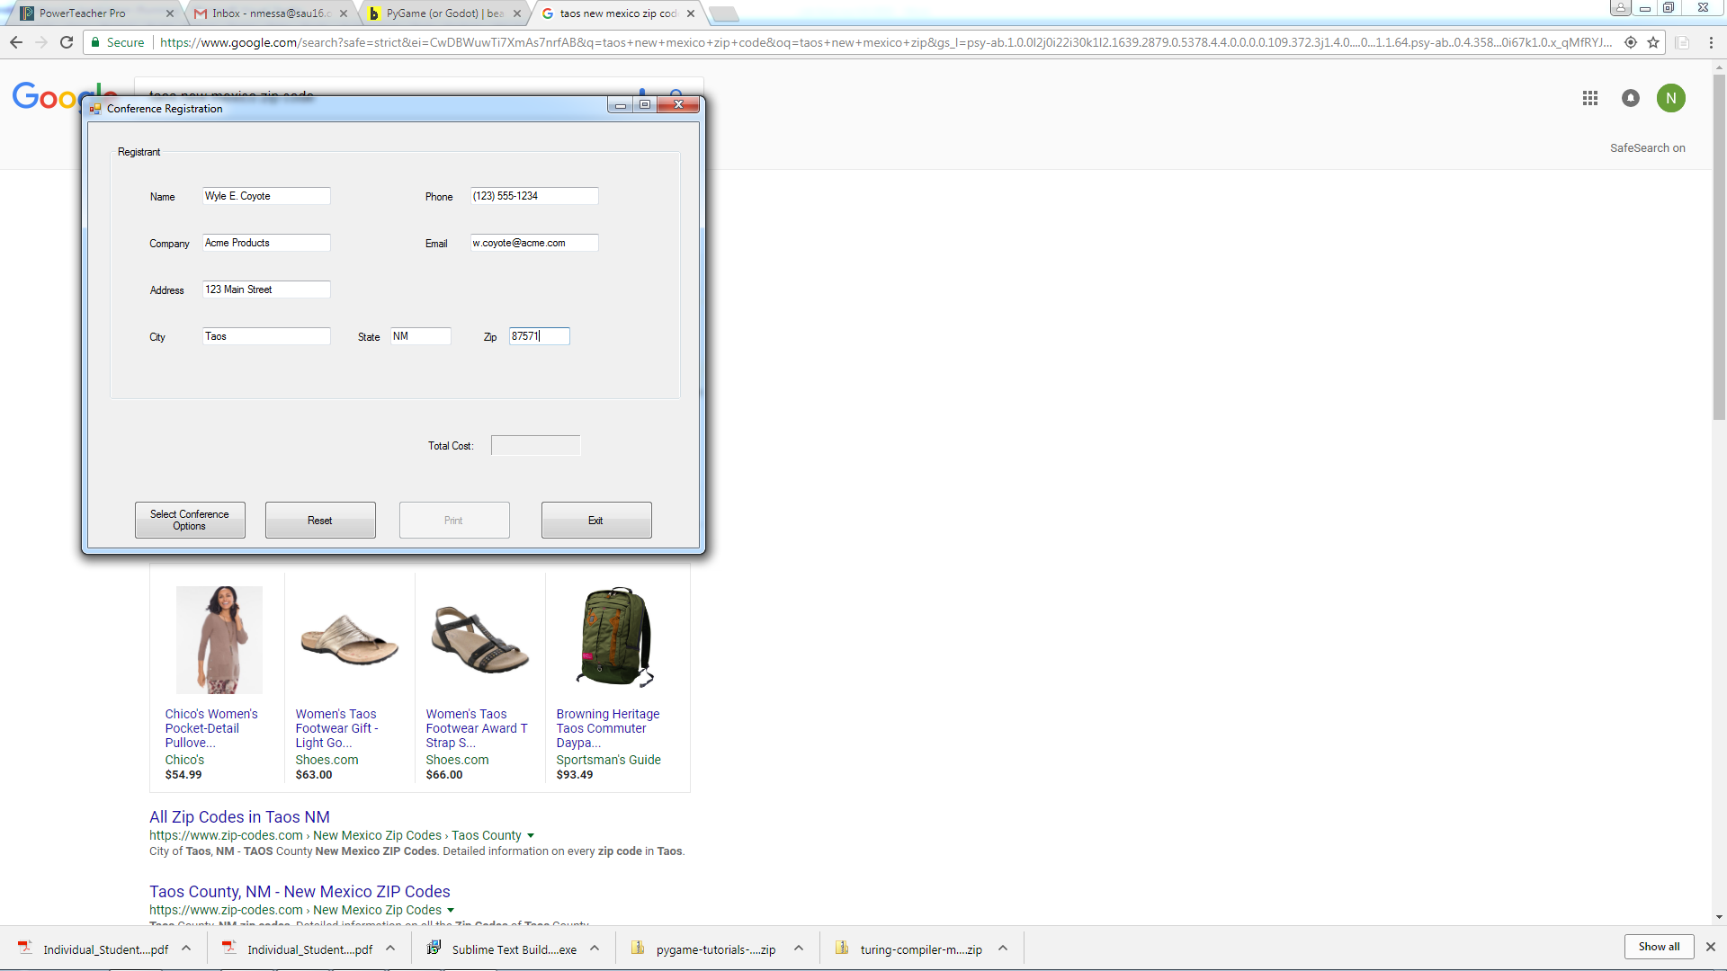

When the user clicks the *Select Conference Options* button, the Conference Options form should appear.

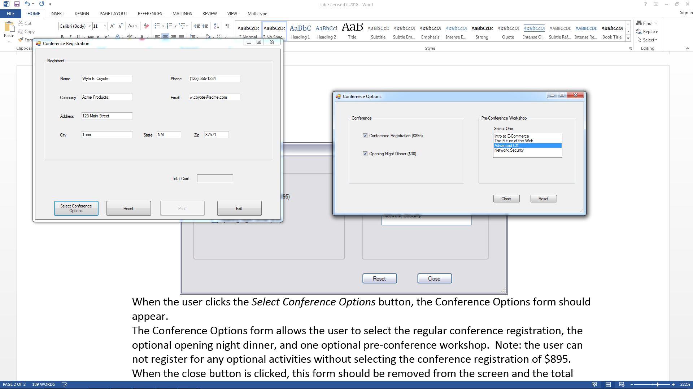

The Conference Options form allows the user to select the regular conference registration, the optional opening night dinner, and one optional pre-conference workshop. Note: the user can not register for any optional activities without selecting the conference registration of $895. When the close button is clicked, this form should be removed from the screen and the total registration fee should appear on the main form.

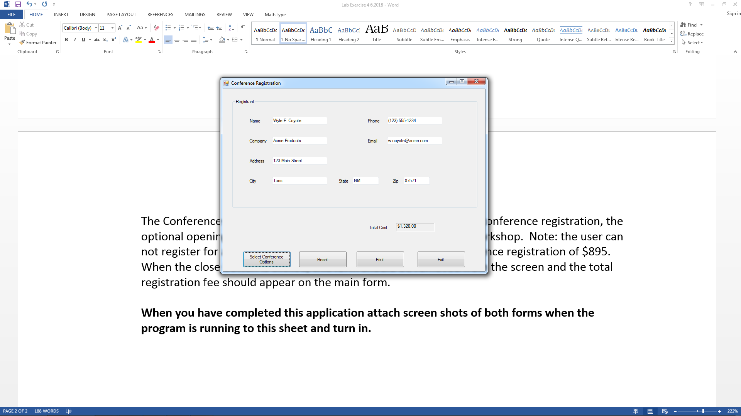

When the Print button is pressed, a Report Form opens and a Print button will print the report.

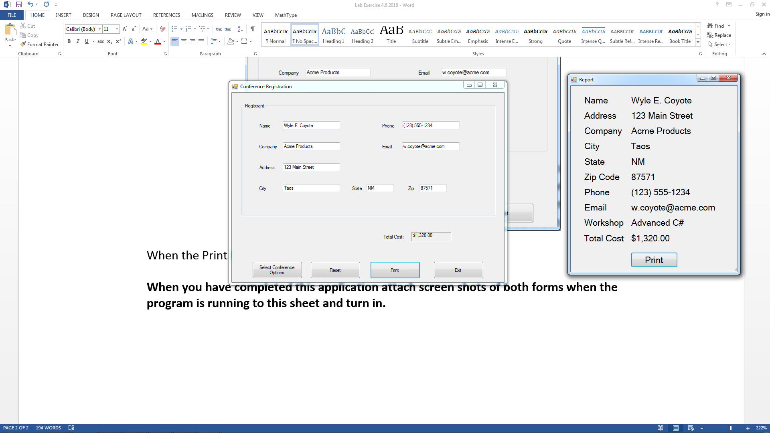

1. We will start by working on the code for frmMain. Add the following public static global variables that are shared with other forms.

public static int total;

public static string workshop;

1. Add the following code to the btnPrint_Click event. Notice that the frmReport constructor is passed 8 textbox objects, 1 label and a string)

frmReport frmPrint = new frmReport(txtName, txtAddress, txtCity, txtState,

txtZip, txtPhone, txtEmail, txtCompany, lblTotal, workshop);

frmPrint.ShowDialog();

btnPrint.Enabled = false;

1. Add the following code to the btnPrint_Click event.

txtAddress.Text = "";

txtCity.Text = "";

txtCompany.Text = "";

txtEmail.Text = "";

txtName.Text = "";

txtPhone.Text = "";

txtState.Text = "";

txtZip.Text = "";

lblTotal.Text = "";

btnPrint.Enabled = false;

txtName.Focus();

1. Add the following code to the btnSelect_Click event.

frmOptions options = new frmOptions();

options.ShowDialog();

lblTotal.Text = total.ToString("c");

btnPrint.Enabled = true;

1. Now we will work on the code for frmOptions.
2. Add the following code to the btnClose_Click event.

//Local variables

int total = 0;

string workshop = "";

if (ckbReg.Checked) //registered for conference

{

total += 895;

if (ckbDinner.Checked) //having dinner

total += 30;

//Add cost and select name of chosen workshop

switch (lstWorkshop.SelectedIndex)

{

case 0:

total += 295;

workshop = lstWorkshop.SelectedItem.ToString();

break;

case 1:

total += 295;

workshop = lstWorkshop.SelectedItem.ToString();

break;

case 2:

total += 395;

workshop = lstWorkshop.SelectedItem.ToString();

break;

case 3:

total += 495;

workshop = lstWorkshop.SelectedItem.ToString();

break;

} //end of switch

//get workshop information back to main form

frmMain.workshop = workshop;

} //end of if

//get total cost infornation back to main form

frmMain.total = total;

//Close current form

this.Close();

1. Now we will work on the code for frmReport.
2. Modify the frmReport constructor to be

public frmReport(TextBox txtName ,TextBox txtAddress, TextBox txtCity, TextBox txtState,

TextBox txtZip, TextBox txtPhone, TextBox txtEmail, TextBox txtCompany,

Label lblTotal, string workshop)

{

InitializeComponent();

//Put all information passed to this form into the report fields for printing

lblName.Text = txtName.Text;

lblAddress.Text = txtAddress.Text;

lblCity.Text = txtCity.Text;

lblState.Text = txtState.Text;

lblZIP.Text = txtZip.Text;

lblPhone.Text = txtPhone.Text;

lblEmail.Text = txtEmail.Text;

lblCompany.Text = txtCompany.Text;

lblWorkshop.Text = workshop;

lblCost.Text = lblTotal.Text;

}

1. Add the following code to the btnPrint_Click event.

printForm1.Print();

this.Close();

1. Now test your application.

**When you complete your application turn in screen shots of all 3 forms in their running state and turnin.**